This dataset contains infusion soft user’s buying behavior. A general dataset looks like:

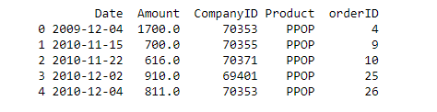

So we have date wise, company wise, product wise order and corresponding purchase amount provided on the dataset. A cohort analysis will provide us retention insight.

Steps:

From each purchase date, we prepared order period which is simply a YYYY-MM-DD date. Then for each company, we found out its minimum purchase date. We called it cohort group. The outcome after adding order period and cohort group column looks like:

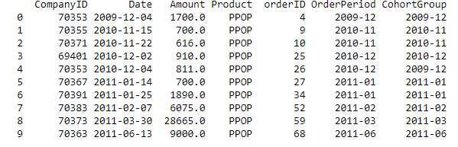

We then calculated number of total companies, total orders, and total amount purchased within each cohort group. We finally got a dataset with cohort period like this:

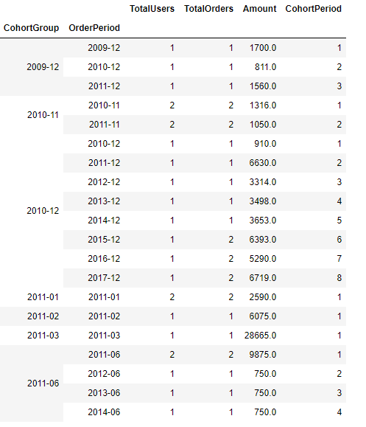

To find retention analysis, we calculated each cohort group size. Then finally we generated our retention dataset based on each company’s first purchase data and onwards, their purchasing history.

Key Findings:

* We can see from the data that fewer users tend to purchase as time goes on.
* For example: User retention for period 2015-12 ended at 25%.
* Strongest cohort correlation observed on 2015-05, 2015-12 etc.
* Other attributes (besides first purchase month) do these companies share which might be causing them to stick around? How were the majority of these users acquired? Was there a specific marketing campaign that brought them in? Did they take advantage of a promotion at sign-up? etc question can be asked.

